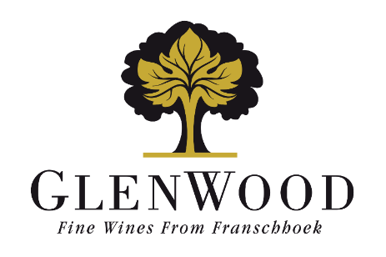
Grand Duc
Chardonnay
2024

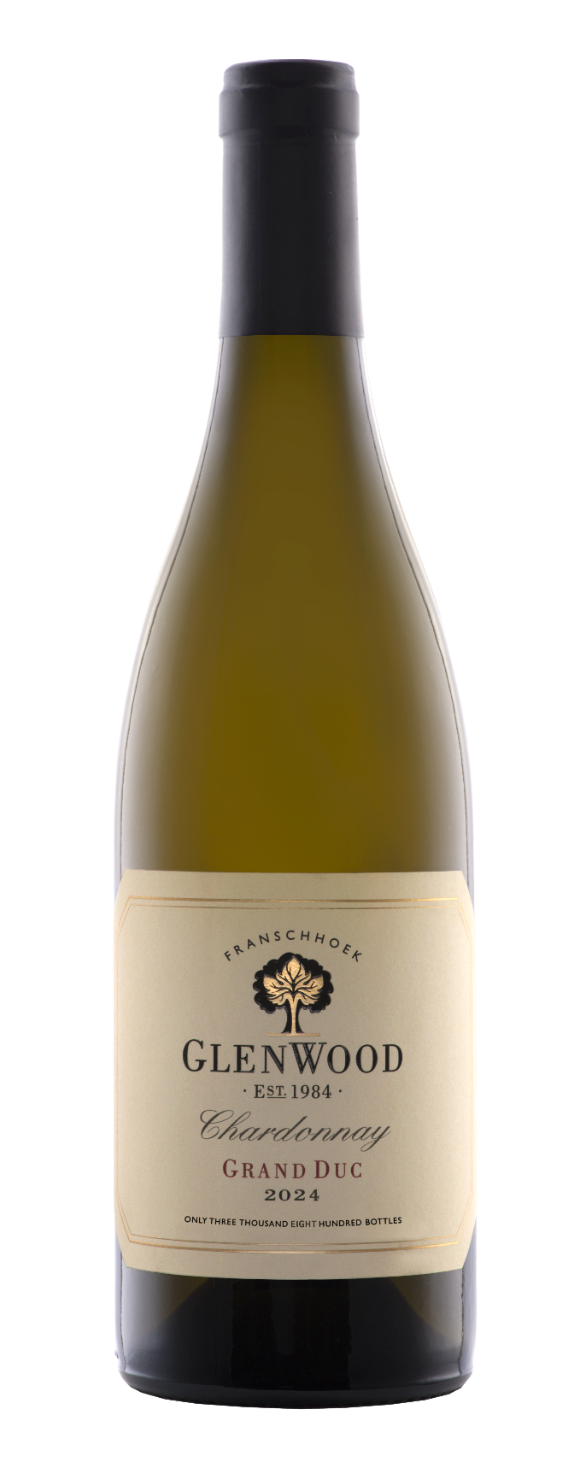 | Viticulture: | Vine age: 28 Years  Density: 4000 vines per hectare  Yield: 6 tons per hectare  A low canopy allowed optimal sunlight penetration. Minimal irrigation was used. The fruit ripened slowly allowing the development of small bunches with highly concentrated flavours.
 | Vinification: | Grapes were picked at 24.7°B and whole-bunch pressed to 1.4 bars of pressure. The juice was left to settle for two days and racked to barrel. Using only wild yeast, fermentation occurred over an 14-day period. The wine spent 20 months on the lees in 100% new 500L French oak barrels.
 | Analysis:
  Alcohol | 14.0%
  Total Acidity | 5.3 g/l
  Residual Sugar | 3.0 g/l
  pH | 3.60
 | Winemaker's Comments: | Straw yellow. Apple crumble, lemon meringue, marzipan and brioche coated by oak spice. Ripe yellow apple and marmalade amplified by oak spice. High oak extraction will benefit from further cellaring.
 | Production: | 3700 750ml bottles
 | Awards: | - Double Gold Gilbert & Gaillard
 | Previous vintages awards: | - 5* Platter 2026 edition  - 91 points – Tim Atkin 2025 report  - Double Gold - Gilbert & Gaillard International Challenge 2025  - 90 points – Trophy Wine Show 2025  - Gold – Clash of the Cultivars 2025  - Gold – Chardonnay Challenge 2025  - Gold – Global Chardonnay Masters 2025

