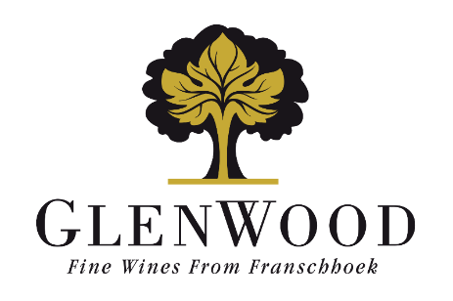
Grand Duc
Semillon
2023
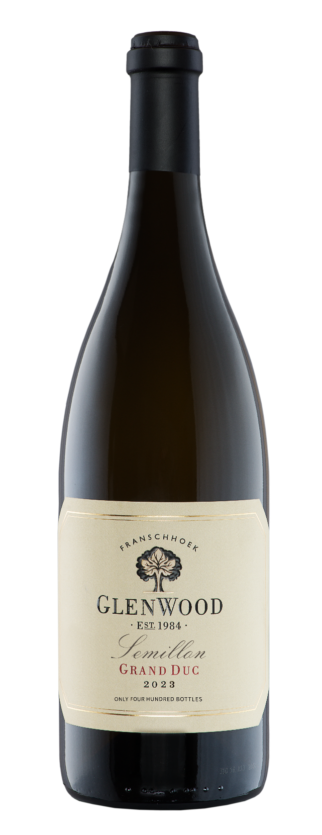 | Viticulture: | Vine age: 28 Years  Density: 6000 vines per hectare  Yield: 15 tons per hectare  A low canopy allowed optimal sunlight penetration. No irrigation was used.
 | Vinification: | Grapes were picked at 21°B, gentle crushed and was cold macerated on the skins for 8 hours before pressing. The juice was left to settle for two days and wild yeast, fermentation occurred over an 9-day period in a stainless steel tank. The wine spent 27 months in a 3rd fill 300L French oak barrel.
 | Analysis:
  Alcohol | 13.5%
  Total Acidity | 6.4 g/l
  Residual Sugar | 1.7 g/l
  pH | 3.40
 | Winemaker's Comments: | Straw yellow. Ripe melon, waxiness coated by spicy oak. Explosive oak and vanilla creaminess on palate entry. A zesty acidity adds freshness, but the brightness thereof demands integration-time. Further cellaring.
 | Production: | 400 750ml bottles
 | Awards: | - Double Gold Medal - Gilbert & Gaillard International Challenge 2026

