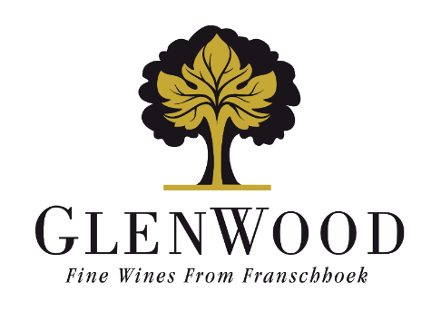
Grand Duc
Syrah
2024

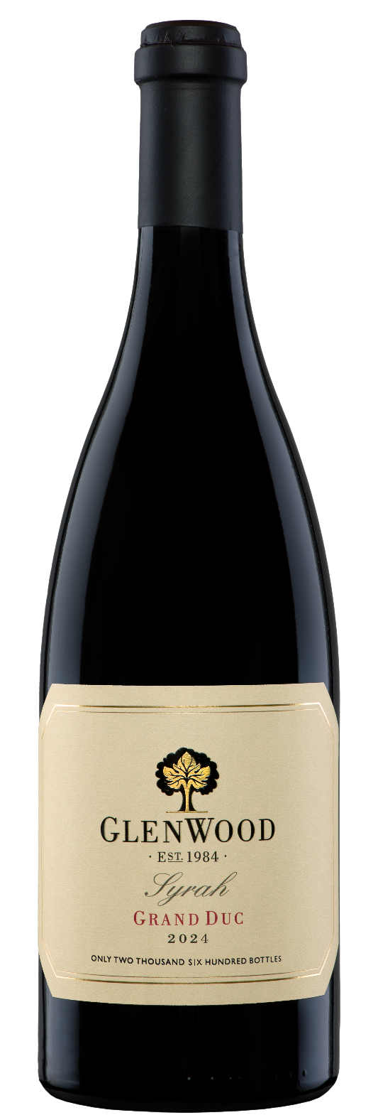 | Viticulture: | Vine age: 30 years  Density: 2645 vines per hectare  Yield: 10.0 tons per hectare
 | Vinification: | Only the best grapes were picked at 23.0°B and 50% whole bunch fermented in small open-top fermenters. Punched down by hand 3 times daily until fermented dry. Grapes were gravity fed to press. After pressing, the wine underwent natural malolactic fermentation in barrel. Wine was matured for 20 months in a selection of 100% new premium French (50%) and American (50%) oak barrels.
 | Analysis:
  Alcohol | 13.5%
  Total Acidity | 5.6 g/l
  Residual Sugar | 2.8 g/l
  pH | 3.72
 | Winemaker's Comments: | Deep ruby in colour with a vibrant purple edge. The nose is expressive and layered, opening with ripe red and black berries, violets and crushed black pepper, followed by subtle notes of clove, vanilla pod and sweet spice. On the palate, the wine is poised and textural, with bright red fruit purity complemented by savoury undertones, and gentle smoky nuances. The finish is long, elegant and complex, with lingering spice and mineral depth. Drink through 2030.  Pairs beautifully with grilled and roasted meats, especially lamb, beef, and duck. The red fruit and spice profile complements herb-crusted lamb, peppered steak, and slow-roasted pork, while the soft tannins suit smoky braais, spiced sausages, and dishes with warm spices. Also excellent with mushroom-based dishes, charcuterie, and semi-hard to hard cheeses like mature Cheddar or Comté.
 | Production: | 2600 750ml bottles
 | Awards: | New Release
 | Previous vintage awards: | - 4.5* Platter 2026 edition  - 92 points – Tim Atkin 2020 report  - 93 points – Gilbert & Gaillard International Challenge 2023

