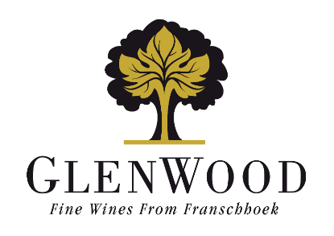

Merlot
2025

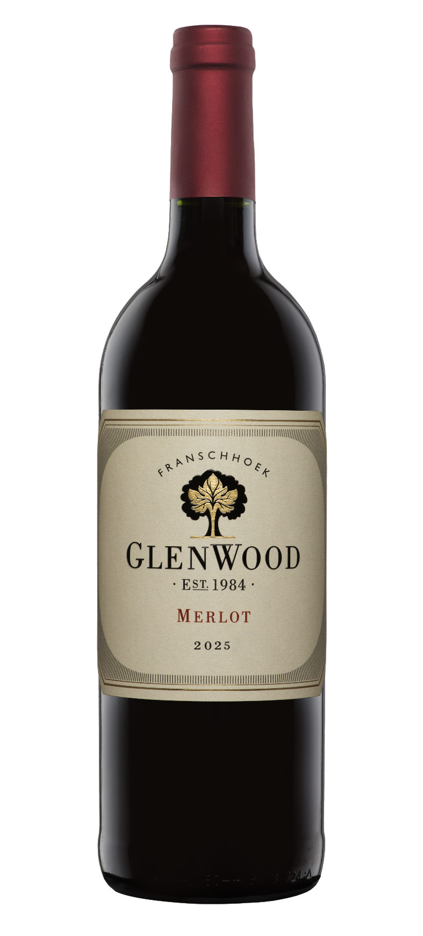 | Viticulture: | Vine density: 5000 vines per hectare  This is a well-balanced vineyard-block.
 | Vinification: | The best quality grapes were selected and picked at optimum tannin ripeness, gently crushed and fermented in small open top fermenters. The wine matured for 12 months in third-fill French oak barrels.
 | Analysis:
  Alcohol | 14.5%
  Total Acidity | 5.7 g/l
  Residual Sugar | 2.9 g/l
  pH | 3.57
 | Winemaker's Comments: | Ruby garnet in colour. Ripe dark berry and plum flavours with subtle oak spice on the nose. Grippy tannins, and a well-rounded finish. Grippy and tart palate with juicy red berry on the aftertaste. Drink through 2030
 | Production: | 4000 750ml bottles

