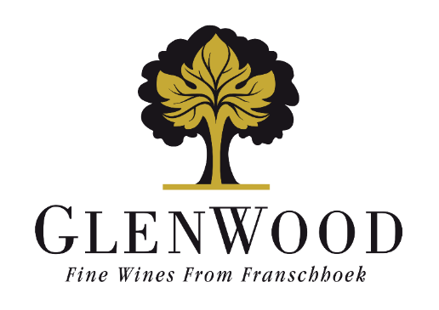
Vigneron’s Selection
Chardonnay
2025

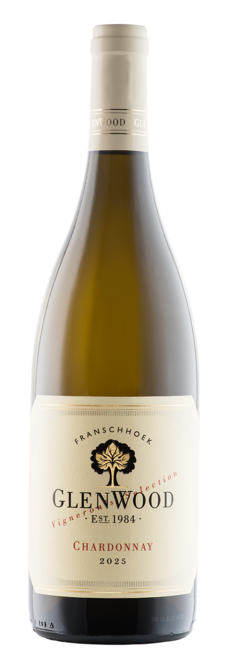 | Viticulture: | Vine age:16 years  A low canopy allowed optimal sunlight penetration. Minimal irrigation was used. The fruit ripened slowly allowing the development of small bunches with highly concentrated flavours.
 | Vinification: | Grapes were picked at 21.5°B and whole-bunch pressed to 1.4 bars of pressure. The juice was left to settle for two days and racked to barrel. Using 100% wild yeast, fermentation occurred over an 18-day period. The wine spent 8 months on the lees in 30% new French oak and 70% second and third fill barrels.
 | Analysis:
  Alcohol | 13.0%
  Total Acidity | 6.0 g/l
  Residual Sugar | 1.7 g/l
  pH | 3.35
 | Winemaker's Comments: | Light yellow and green tint. Zesty citrus, spicy oak undertone, with some brioche influence. Ripe yellow apple and quinch nuances coated by oak creaminess, carries all elements for further integration. Drink now or keep for next 3-5 years.
 | Production: | 6000 750ml bottles
 | Awards: | - Gold Medal - Gilbert & Gaillard International Challenge 2026
 | Previous Vintages Awards: | - 5* Platter 2023 edition Highly recommended Platter 2022 edition  - 92 points Gilbert & Gaillard International Challenge 2025

